Three processes are scheduled according to Round Robin (RR) with quantum=5ms.

|  |  |  |
| --- | --- | --- |
| Process | Arrive time (ms) | Processing time (ms) |
| Process 1 | 0 | 37 |
| Process 2 | 6 | 29 |
| Process 3 | 15 | 21 |

Your Task: Calculate the parameter of each process

1) Average waiting time

2) Average complete time

3) Average Turnaround Time

Solution:

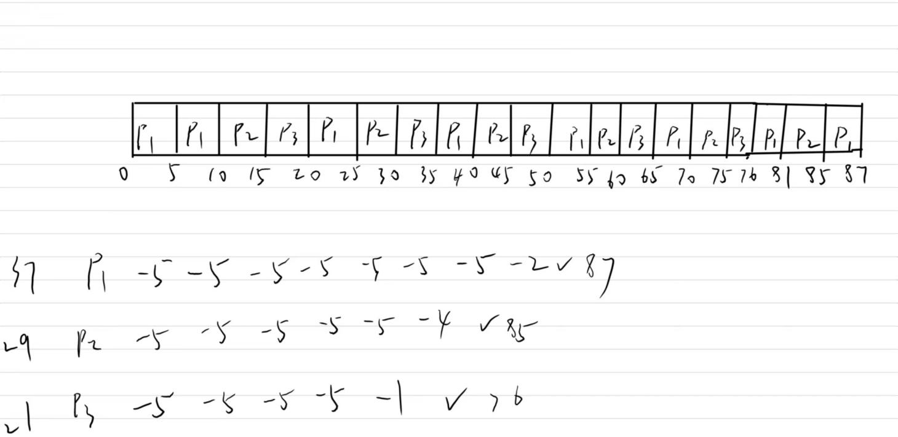

1. Waiting time:

P1: (0-0)+(20-10)+(35-25)+(50-40)+(65-55)+(76-70)+(85-81) ms=50ms

P2: (10-6)+(25-15)+(40-30)+(55-45)+(70-60)+(81-75) ms=50ms

P3: (15-15)+(30-20)+(45-35)+(60-50)+(75-65) ms=40ms

Average waiting time=(50ms+50ms+40ms)/3=46.7ms

1. complete time:

P1: 87ms P2: 85ms P3:76ms

Average complete time=(87ms+85ms+76ms)/3=82.7ms

1. Turnaround Time:

P1: 87ms-0ms=87ms

P2: 85ms-6ms=79ms

P3: 76ms-15ms=61ms

Average Turnaround Time=(87ms+79ms+61ms)/3=75.7ms